Case 4-Asia-Sassanian-Seal-Cameo-Carnelian-600 CE

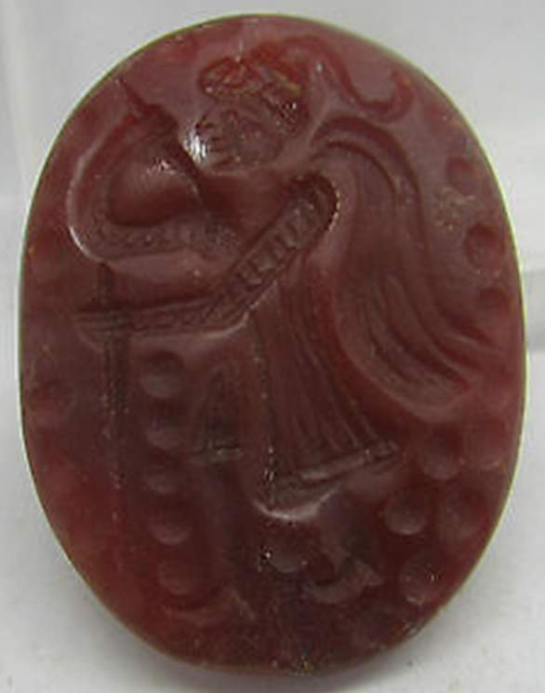 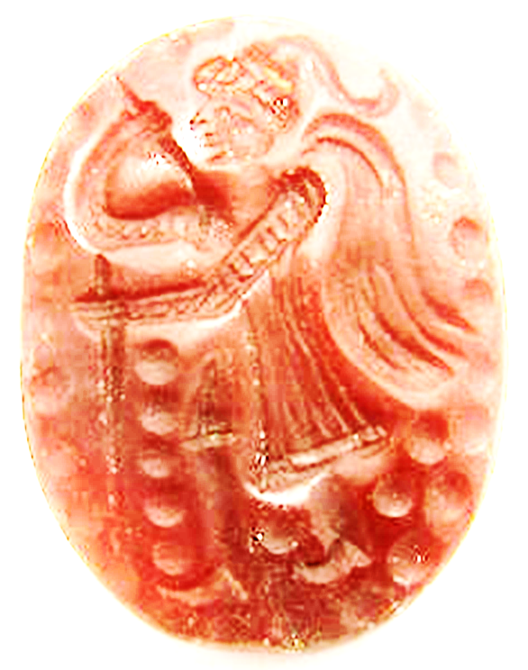

#### Sassanian carnelian cameo C. 600AD

|  |  |
| --- | --- |
| Item price | GBP 60.00 |
| Quantity | 1 |
| Item number | 152065171403 |